**DSA PRACTICE PROBLEMS DATE:14/11/24**

1.Given a **sorted** array**arr.** Return the size of the modified array which contains only distinct elements.  
*Note:*  
1.Don't use set or HashMap to solve the problem.  
2. You **must** return the modified array **size only**where distinct elements are present and **modify** the original array such that all the distinct elements come at the beginning of the original array

**Input:** arr = [2, 2, 2, 2, 2]

**Output:** [2]

**Explanation:** After removing all the duplicates only one instance of 2 will remain i.e. [2] so modified array will contains 2 at first position and you should **return 1** after modifying the array, the driver code will print the modified array elements.

CODE:

class Solution {

public int remove_duplicate(List<Integer> arr) {

if (arr == null || arr.size() == 0) {

return 0;

}

int uniqueIndex = 0;

for (int i = 1; i < arr.size(); i++) {

if (!arr.get(i).equals(arr.get(uniqueIndex))) {

uniqueIndex++;

arr.set(uniqueIndex, arr.get(i));

}

}

return uniqueIndex + 1;

}

}

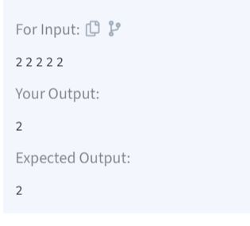

Time Complexity:O(n)

2. Given an array **arr[],** find the first repeating element. The element should occur more than once and the index of its first occurrence should be the smallest.

**Note:-**The position you return should be according to 1-based indexing.

**Input:** arr[] = [1, 5, 3, 4, 3, 5, 6]

**Output:** 2

**Explanation:** 5 appears twice and its first appearance is at index 2 which is less than 3 whose first the occurring index is 3.

CODE:

class Solution {

public static int firstRepeated(int[] arr) {

HashMap<Integer, Integer> map = new HashMap<>();

int minIndex = Integer.MAX_VALUE;

for (int i = 0; i < arr.length; i++) {

if (map.containsKey(arr[i])) {

minIndex = Math.min(minIndex, map.get(arr[i]));

} else {

map.put(arr[i], i);

}

}

return (minIndex == Integer.MAX_VALUE) ? -1 : minIndex + 1;

}

}

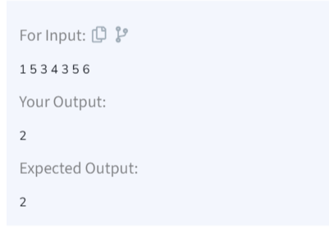

Time Complexity:O(n)

3. Given a **sorted array, arr[]**containing only **0s**and **1s**, find the **transition point**, i.e., the **first index**where **1**was observed, and **before that**, only 0 was observed.  If **arr** does not have any **1**, return **-1**. If array does not have any **0**, return **0**.

**Input:** arr[] = [0, 0, 0, 1, 1]

**Output:** 3

**Explanation:** index 3 is the transition point where 1 begins.

CODE:

class Solution {

int transitionPoint(int arr[]) {

int n=arr.length;

for(int i=0;i<n;i++){

if(arr[i]==1){

return i;

}

}

return -1;

}

}

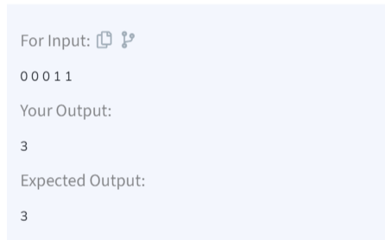

Time Complexity:O(n)

4. Given a **sorted** array **arr[]** of distinct integers. Sort the array into a wave-like array(In Place). In other words, arrange the elements into a sequence such that arr[1] >= arr[2] <= arr[3] >= arr[4] <= arr[5].....  
If there are multiple solutions, find the lexicographically smallest one.

**Note:**The given array is sorted in ascending order, and you don't need to return anything to change the original array.

**Input:** arr[] = [1, 2, 3, 4, 5]

**Output: [**2, 1, 4, 3, 5]

**Explanation:** Array elements after sorting it in the waveform are 2, 1, 4, 3, 5.

CODE:

class Solution {

public static void convertToWave(int[] arr) {

for (int i = 0; i < arr.length - 1; i=i+2) {

int temp = arr[i];

arr[i] = arr[i + 1];

arr[i + 1] = temp;

}

}

}

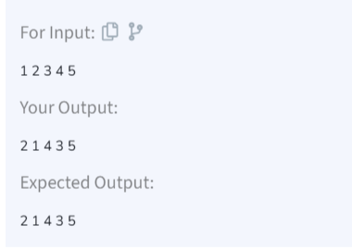

Time Complexity:O(n)

5.Given a sorted array **arr** with possibly some duplicates, the task is to find the first and last occurrences of an element **x** in the given array.  
**Note:** If the number **x** is not found in the array then return both the indices as -1.

**Input:** arr[] = [1, 3, 5, 5, 5, 5, 67, 123, 125], x = 5

**Output:** [2, 5]

**Explanation**: First occurrence of 5 is at index 2 and last occurrence of 5 is at index 5

CODE:

package util;

public class occurance {

public static int[] findFirstAndLast(int[] arr, int x) {

int[] result = {-1, -1};

result[0] = *findOccurrence*(arr, x, true);

result[1] = *findOccurrence*(arr, x, false);

return result;

}

private static int findOccurrence(int[] arr, int x, boolean findFirst) {

int low = 0, high = arr.length - 1;

int result = -1;

while (low <= high) {

int mid = low + (high - low) / 2;

if (arr[mid] == x) {

result = mid;

if (findFirst) {

high = mid - 1;

} else {

low = mid + 1;

}

} else if (arr[mid] < x) {

low = mid + 1;

} else {

high = mid - 1;

}

}

return result;

}

public static void main(String[] args) {

int[] arr = {1, 3, 5, 5, 5, 5, 67, 123, 125};

int x = 5;

int[] result = *findFirstAndLast*(arr, x);

System.***out***.println("First and Last Occurrences: [" + result[0] + ", " + result[1] + "]");

}

}

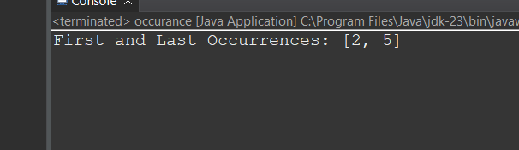

Time Complexity:O(logn)

6. The cost of stock on each day is given in an array **price[]**. Each day you may decide to either buy or sell the stock i at **price[i]**, you can even buy and sell the stock on the same day. Find the **maximum profit** that you can get.

Note: A stock can only be sold if it has been bought previously and multiple stocks cannot be held on any given day.

**Input:** prices[] = [100, 180, 260, 310, 40, 535, 695]  
**Output:** 865  
**Explanation:** Buy the stock on day 0 and sell it on day 3 => 310 – 100 = 210. Buy the stock on day 4 and sell it on day 6 => 695 – 40 = 655. Maximum Profit = 210 + 655 = 865.

CODE:

package util;

public class buyandsell {

public static int maxProfit(int[] prices) {

int maxProfit = 0;

for (int i = 1; i < prices.length; i++) {

if (prices[i] > prices[i - 1]) {

maxProfit += prices[i] - prices[i - 1];

}

}

return maxProfit;

}

public static void main(String[] args) {

int[] prices = {100, 180, 260, 310, 40, 535, 695};

System.***out***.println("Maximum Profit: " + *maxProfit*(prices));

}

}

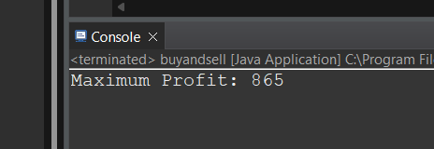

Time Complexity:O(n)

7. Given an integer array **coins[ ]**representing different denominations of currency and an integer **sum**, find the number of ways you can make **sum** by using different combinations from coins[ ].   
Note: Assume that you have an infinite supply of each type of coin. And you can use any coin as many times as you want.  
Answers are guaranteed to fit into a 32-bit integer.

**Input:** coins[] = [1, 2, 3], sum = 4

**Output:** 4

**Explanation**: Four Possible ways are: [1, 1, 1, 1], [1, 1, 2], [2, 2], [1, 3].

CODE:

package util;

public class coinchange {

public static int countWays(int[] coins, int sum) {

int[] dp = new int[sum + 1];

dp[0] = 1;

for (int coin : coins) {

for (int i = coin; i <= sum; i++) {

dp[i] += dp[i - coin];

}

}

return dp[sum];

}

public static void main(String[] args) {

int[] coins = {1, 2, 3};

int sum = 4;

System.***out***.println("Number of ways to make sum " + sum + ": " + *countWays*(coins, sum));

}

}

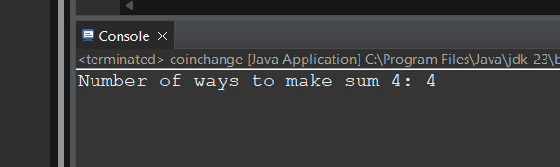

TimeComplexity:O(n*sum)

8. Given an array **arr** of positive integers. The task is to return the maximum of **j - i** subjected to the constraint of **arr[i] < arr[j]**and **i < j**.

**Input:** arr[] = [1, 10]

**Output:** 1

**Explanation:** arr[0] < arr[1] so (j-i) is 1-0 = 1.

CODE:

package util;

public class maxindex{

public static int maxIndexDiff(int[] arr) {

int n = arr.length;

if (n < 2) return 0;

int[] leftMin = new int[n];

int[] rightMax = new int[n];

leftMin[0] = arr[0];

for (int i = 1; i < n; i++) {

leftMin[i] = Math.*min*(arr[i], leftMin[i - 1]);

}

rightMax[n - 1] = arr[n - 1];

for (int j = n - 2; j >= 0; j--) {

rightMax[j] = Math.*max*(arr[j], rightMax[j + 1]);

}

int i = 0, j = 0, maxDiff = -1;

while (i < n && j < n) {

if (leftMin[i] < rightMax[j]) {

maxDiff = Math.*max*(maxDiff, j - i);

j++;

} else {

i++;

}

}

return maxDiff;

}

public static void main(String[] args) {

int[] arr1 = {1, 10};

System.***out***.println("Maximum Index Difference: " + *maxIndexDiff*(arr1));

int[] arr2 = {1, 2, 3, 4, 5, 6};

System.***out***.println("Maximum Index Difference: " + *maxIndexDiff*(arr2));

int[] arr3 = {7, 1, 3, 4, 5, 2};

System.***out***.println("Maximum Index Difference: " + *maxIndexDiff*(arr3));

}

}

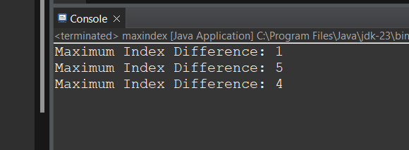

Time Complexity:O(n)